Asia-China-Coin-4.4-R5

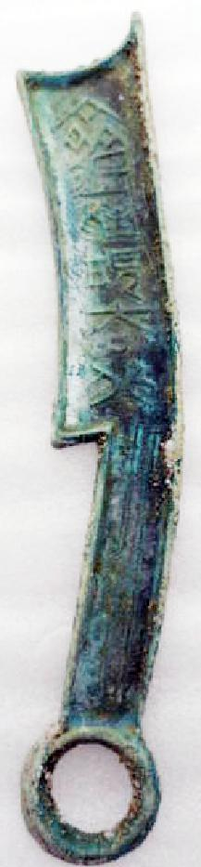 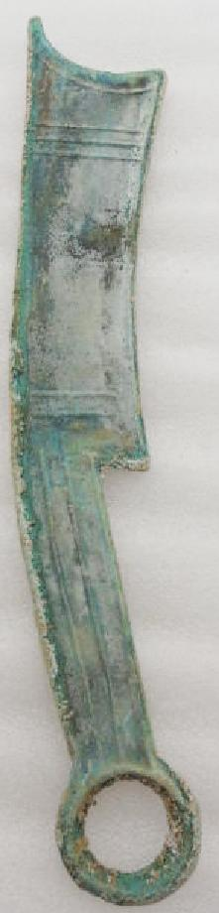

40g

size : 7.0 inches\*1.1 inches